**DAILY ONLINE ACTIVITIES SUMMARY**

|  |  |  |  |  |  |  |  |  |
| --- | --- | --- | --- | --- | --- | --- | --- | --- |
| **Date:** | **16/6/2020** | | | | | **Name:** | **Apoorva U** | |
| **Sem & Sec** | **8th Sem** | | | | | **USN:** | **4AL16CS017** | |
| **Online Test Summary** | | | | | | | | |
| **Subject** | | **BDA** | | | | | | |
| **Max. Marks** | | **30** | | **Score** | | | **28** | |
| **Certification Course Summary** | | | | | | | | |
| **Course** | **Introduction To SQL** | | | | | | | |
| **Certificate Provider** | | | **datacamp** | | **Duration** | | | **4hrs** |
| **Coding Challenges** | | | | | | | | |
| **Problem Statement:**  Given a string input Count all lowercase, uppercase, digits, and special symbols. | | | | | | | | |
| **Status:COMPLETED** | | | | | | | | |
| **Uploaded the report in Github** | | | | | **yes** | | | |
| **If yes Repository name** | | | | | **Apoorva_u** | | | |
| **Uploaded the report in slack** | | | | | **yes** | | | |

Online Test Details: (Attach the snapshot and briefly write the report for the same)

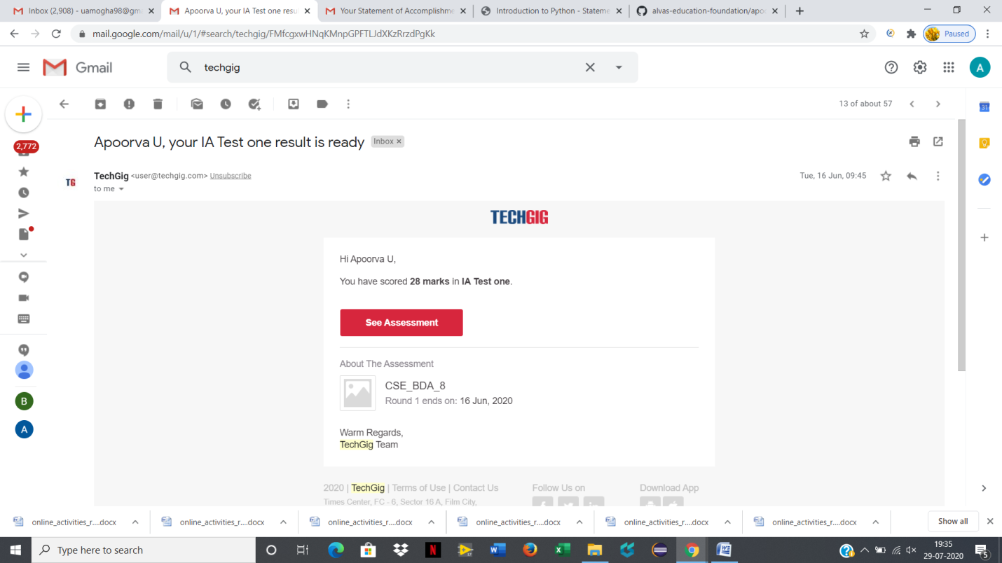

Certification Course Details: (Attach the snapshot and briefly write the report for the same)

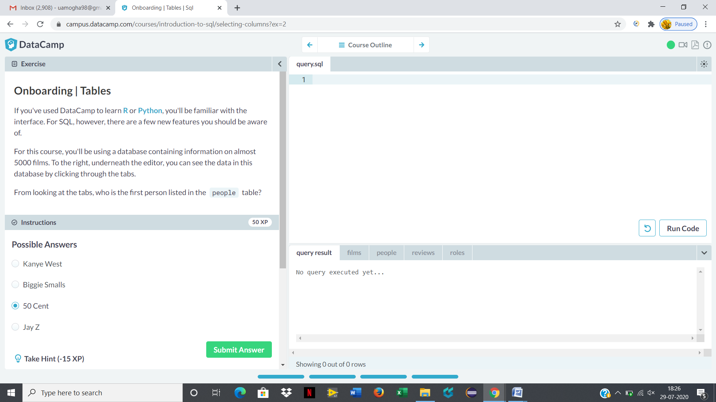

Coding Challenges Details: (Attach the snapshot and briefly write the report for the same)

Given a string input Count all lowercase, uppercase, digits, and special symbols.

def findDigitsCharsSymbols(inputString):

words=inputString.split()

charCount=0

digitCount=0

symbolCount=0

for char in inputString:

if char.islower()or char.isupper():

charCount+=1

elif char.isnumeric():

digitCount+=1

else:

symbolCount+=1

print("Chars=",charCount,"Digits=",digitCount,"Symbol=",symbolCount)

inputString="P@#yn2"

print("total counts of chars, digits, and symbols")

print(findDigitsCharsSymbols(inputString))